- Hands-on Subnetting Practical

Q.1 Given a network address of 192.168.10.0/24, divide it into 4 equal subnets and write down the subnet mask, network address, and broadcast address for each subnet?

Answer

- Divide 192.168.10.0/24 into 4 Equal Subnets
Given network:
192.168.10.0/24
To create 4 equal subnets, we borrow 2 bits.
New prefix:
/26
- Subnet Mask:
255.255.255.192

Each subnet has 64 total addresses.
Subnet | Network Address | Subnet Mask | Broadcast Address
- Subnet 1 | 192.168.10.0/26 | 255.255.255.192 | 192.168.10.63
- Subnet 2 | 192.168.10.64/26 | 255.255.255.192 | 192.168.10.127
- Subnet 3 | 192.168.10.128/26 | 255.255.255.192 | 192.168.10.191
- Subnet 4 | 192.168.10.192/26 | 255.255.255.192 | 192.168.10.255

Q.2 For one of the subnets you created, assign valid IP addresses to 5 devices (such as a router, two laptops, a printer, and a mobile) and list which IP goes to which device.<br><br><em><strong>Hint:</strong> Make sure not to use the network or broadcast address for any device.</em>?

Answer

- I selected Subnet 1: 192.168.10.0/26
Usable host range:
192.168.10.1 – 192.168.10.62

Device | Assigned IP Address
Router | 192.168.10.1
Laptop 1 | 192.168.10.10
Laptop 2 | 192.168.10.20
Printer | 192.168.10.30
Mobile | 192.168.10.40

The network address 192.168.10.0 and broadcast address 192.168.10.63 are not assigned to any device.

Q.3 Draw a simple diagram (hand-drawn or digital) showing your subnet plan: label each subnet, the range of IPs, and where each device is connected?

Answer
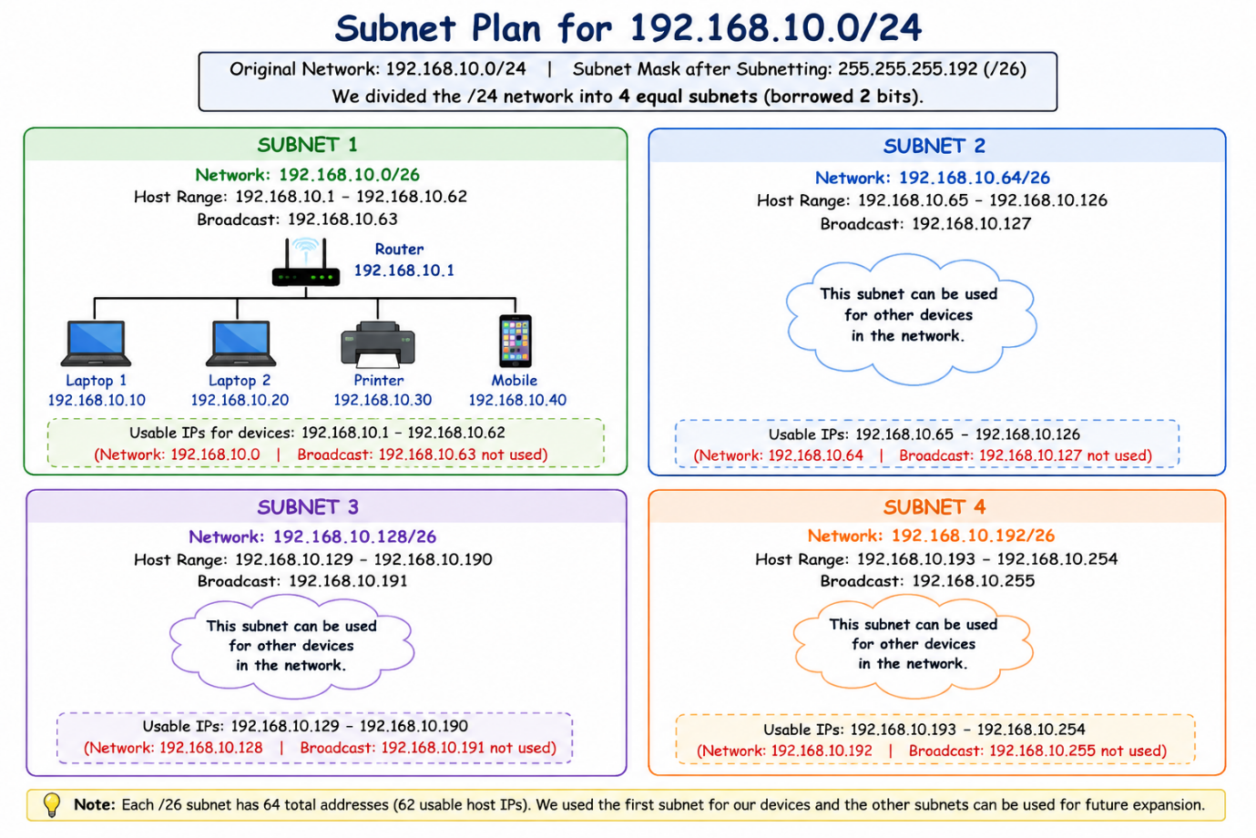

- The diagram shows the four /26 subnets created from the 192.168.10.0/24 network. Subnet 1 is used for the router, two laptops, printer, and mobile device. The other three subnets are kept for other devices or future use. Each subnet has 62 usable host IP addresses.

Q.4 Document step-by-step how you calculated the subnet mask, number of hosts per subnet, and assigned IP addresses for your plan, as if you are explaining it to a friend who is new to subnetting?

Answer

- Step-by-Step Subnetting Calculation
The original network is:
192.168.10.0/24
A /24 network has 8 host bits.
We need 4 equal subnets.
- Step 1: Find how many bits to borrow
To create 4 subnets:
2² = 4
So, we borrow 2 bits.
- Step 2: Find the new subnet mask
Original prefix: /24
Borrowed bits: 2
New prefix: /26
Subnet Mask:
255.255.255.192
- Step 3: Find addresses per subnet
Host bits remaining:
32 - 26 = 6 bits
Total addresses:
2⁶ = 64
Usable hosts:
64 - 2 = 62
So, each subnet has:
64 total addresses
62 usable host addresses
- Step 4: Find the subnet ranges
The block size is:
256 - 192 = 64
So the subnets start at:
0, 64, 128, 192
- Therefore:
- Subnet 1: 192.168.10.0 – 192.168.10.63
- Subnet 2: 192.168.10.64 – 192.168.10.127
- Subnet 3: 192.168.10.128 – 192.168.10.191
- Subnet 4: 192.168.10.192 – 192.168.10.255
- Step 5: Assign device IPs
For Subnet 1, the usable range is:
192.168.10.1 – 192.168.10.62
- I assigned:
- Router: 192.168.10.1
- Laptop 1: 192.168.10.10
- Laptop 2: 192.168.10.20
- Printer: 192.168.10.30
- Mobile: 192.168.10.40
This keeps all device addresses inside the valid host range and avoids using the network and broadcast addresses.

